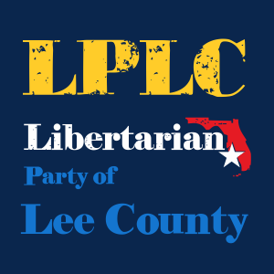

May 4, 2022
Meeting

Mission Statement:
The Libertarian Party of Lee County exists to:
- Elect candidates who support libertarian principles;
- Educate members and others on the principles of liberty;
- Engage elected officials and the public to effect political change.

The LPLC Newsletter
Please consider contributing news, relevant links, and opinion pieces. Contributions should be submitted to: Secretary@leelibertarians.org

Upcoming Events:
LP National Convention in Reno, NV – May 26-29, 2022
Next Board of County Commissioners Meeting- May 17th 9:30am

Next LPLC Meeting – June 1st 6:30 – Crowne Plaza (watch Facebook/email for confirmation of location)
Guest speaker Gwyn Gittens- Lee County School Board

Libertarian Party of Lee County
May 4, 2022

- Welcome and Agenda Overview
- Treasurer Report
- Vice Chair Report
- Chair Report
- Visitor Introduction

Speaker Introduction

Board of County Commissioners
Meetings- cancelled yesterday

______________________________________________________________
______________________________________________________________
______________________________________________________________
______________________________________________________________
______________________________________________________________
______________________________________________________________
______________________________________________________________
______________________________________________________________
______________________________________________________________
______________________________________________________________
______________________________________________________________
______________________________________________________________
______________________________________________________________
______________________________________________________________
______________________________________________________________

