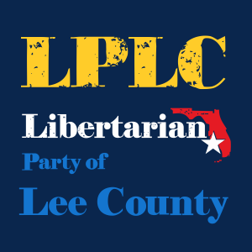

July 6, 2022
Business Meeting

Mission Statement:
The Libertarian Party of Lee County exists to:
- Elect candidates who support libertarian principles;
- Educate members and others on the principles of liberty;
- Engage elected officials and the public to effect political change.

The LPLC Newsletter
Please consider contributing news, relevant links, and opinion pieces. Contributions should be submitted to: Secretary@leelibertarians.org

Upcoming Events:
Next Board of County Commissioners Meeting- Tues Aug 2nd 9:30am
Upcoming Elections- Tues August 23rd- Primaries
Next LPLC Meeting – August 3rd 6:30 – Social Meeting Crowne Plaza (watch Facebook/email for confirmation of location)

Libertarian Party of Lee County
July 6, 2022

- Welcome and Agenda Overview
- Treasurer Report
- Vice Chair Report
- Chair Report
- Member Roll Call
- Secretary position

Speaker Introduction- Gwynetta Gittens LCSB Dist. 5

______________________________________________________________
______________________________________________________________
______________________________________________________________
______________________________________________________________
______________________________________________________________
______________________________________________________________
______________________________________________________________
______________________________________________________________
______________________________________________________________
______________________________________________________________
______________________________________________________________
______________________________________________________________
______________________________________________________________
______________________________________________________________
______________________________________________________________

